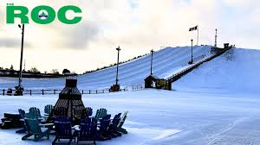 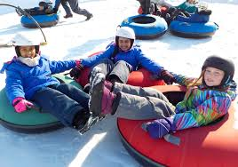

Dear Hockey Team Manager’s

Looking for a fun activity to keep your team energized and connected during your upcoming tournament?

The ROC offers the perfect opportunity for your players to unwind and enjoy the slopes during your visit to Georgina for the Lake Simcoe Winter Classic!

The ROC offers skiing, snowboarding, snow tubing and snowshoeing (rental equipment available onsite for a fee) - a great way to bond as a team, stay active, and create unforgettable memories.

All-access tickets are available online. The ROC offers group discounts for groups of 20 or more people (we suggest calling 905-476-8834 to book a large group.

You can easily reserve a time block of your choice by visiting our [Rates and Reservations page.](https://www.georgina.ca/roc/roc-winter-season/rates-and-reservations)

Pre-registering ensures your team will have access to the slopes at your preferred time.

Don’t miss out on this exciting opportunity to add a little winter fun to your tournament schedule! If you have any questions or special requests, feel free to reach out—we’d be happy to help.

We look forward to hosting your team on the mountain!

Warm regards,

The ROC Admin Team

905-476-8834

[georginaroc@georgina.ca](mailto:georginaroc@georgina.ca)

